1)

**IPL 2022: Ranking all teams based on their strongest playing XIs**

The participating teams have their squads ready now to set the tournament on fire. The mega **Indian Premier League (IPL)** auction was good for all the teams, and all of them looked satisfied with the resources they got. Only 204 out of 590 players in the auction managed to get contracts. The teams had varied strategies, and it remains to be seen which one was effective.

The teams will find it difficult to put across their playing XIs as they will have a problem of plenty. All of the teams have a huge amount of talent. The teams will have to make tough calls while selecting their first-choice XI. Who sits on the bench? It can be a hard thing to crack.

The competition is going to be more thrilling, as two brand new teams are set to be part of the 15th edition of the IPL. A quality playing XI of an IPL team forms with the combination of good domestic Indian players, and established international cricket stars.

**Here we rank the 10 IPL 2022 teams based on their strongest playing XIs:**

**10. Gujarat Titans**

It will be fair to say that the Titans could have done better at the auction. At times, they looked clueless while bidding. Till the last session of the auction, they did not have a single wicket-keeper. They went for Matthew Wade and Wriddhiman Saha in the dying moments of the event. It will be very interesting to see who opens with Shubman Gill, as Jason Roy has opted out from the season.

The South African star David Miller can be seen finishing games at number five, with skipper **Hardik Pandya** at number six. Rahul Tewatia can be a trump card for them down the order. Rashid Khan is expected to be the most valuable player for them, and he can be partnered by Rahul Tewatia in the spin bowling department. Mohammed Shami, Lockie Ferguson, and Pradeep Sangwan will probably form the pack attack.

**9. Sunrisers Hyderabad**

The Hyderabad-based franchise had the most surprising retention ahead of the auction. Their decision of letting David Warner and Rashid Khan go was surprising, to say the least. They have tried to form their line-up around **Kane Williamson**, who will lead the team. Hyderabad started their bidding quite late at the auction as they were seen backing their previous players.

The young all-rounders Abdul Samad and Abhishek Sharma will have the responsibility of finishing games for them at number five and six. The latest West Indian sensation Romario Shephard can be seen batting at number seven for them. Washington Sundar will have a big role to play for the franchise, too. He will be partnered by Shreyas Gopal during the spin-bowling at the middle overs. Bhuvi and Natarajan are their first-choice pacers.

**8. Kolkata Knight Riders**

The Kolkata Knight Riders had a relief on their faces when they purchased **Shreyas Iyer**, as they desperately needed a solid skipper. The Indian batter has been named the skipper of the KKR for the 2022 season. They retained Andre Russell, Sunil Narine, Venkatesh Iyer, and Varun Chakravarthy, ahead of the mega auction.

**7. Rajasthan Royals**

Rajasthan Royals also had a decent auction. Their problem now is that they have a lot of top-order batters. As a result, it can be tricky for the management to select three or four of them. Sanju Samson will lead the team this season, too, and Rajasthan will have a lot of hopes from him as a batter. On the other hand, they have a good-looking bowling line-up.

**6. Punjab Kings**

Punjab Kings was the franchise with the least number of retentions. They retained Mayank Agarwal and Arshdeep Singh. Just like every season, PBKS was looking to build a fresh and new team in 2022, too. Punjab went to the auction with the biggest purse, and they were quite busy while bidding for the players at the event. They have successfully assembled a decent squad.

**5. Mumbai Indians**

The most successful team in the history of IPL spent more than 10 crores on a single player for the first time in the auction. They went berserk while picking Ishan Kishan. MI has been a franchise that has backed its core. They invest in their familiar faces and build a team around them. Despite the Pandya brothers’ departure from the team, they still look very good.

The skipper Rohit Sharma is one of the best openers in the shortest format, and this time the pocket-size dynamo Ishan Kishan can accompany him who is a dependable gloveman, too. Suryakumar Yadav has been MI’s number three for a good time now, and his role will not be different from other seasons. Mumbai can use Tilak Verma as their number four who is a promising player.

**4. Royal Challengers Bangalore**

The IPL franchise with the biggest fan base has not done many wonders in the Indian Premier League. The franchise will not be the same anymore as **AB de Villers** has decided to take retirement from all forms of the game, and their skipper Virat Kohli has decided to quit captaincy. RCB have announced that Faf du Plessis will lead the franchise this season.

**3. Chennai Super Kings**

Chennai Super Kings has a good mixture of experienced and young guys in their squad. They have this time has picked some young, budding cricketers who can serve the franchise for many more seasons. The big news is that Suresh Raina has not been picked by CSK, which was a surprising decision by

The face of CSK, **MS Dhoni**, will continue his role which he has been doing since 2008. The MVP of CSK, Ravindra Jadeja, has evolved as a batter, and there never was a doubt about his bowling. Jadeja will be the most important player for CSK. With Deepak Chahar getting injured, we can see someone like Tushar Deshpande and KM Asif replacing him in the first few matches in his absence. Bravo and Milne can be the first-choice pacers with a good spin option in the form of Santner.

**2. Delhi Capitals**

Delhi Capitals were the busiest franchise at the mega auction. They sealed some quality deals at the event. **Rishabh Pant** did well captaining Delhi last year, and will continue doing the same thing in 2022 too. DC have some stand-out match-winners of the 20-over format, and they have successfully assembled one of the strongest squads.

1. **Lucknow Super Giants**

It will not be any wrong to say that the Lucknow Super Giants have managed to get the best-looking squad among all the teams. The Lucknow-based franchise is taking part for the first time, and is expected to do well in their inaugural season. They have named **KL Rahul** as their captain for the season, who was a draft pick alongside Marcus Stoinis and Ravi Bishnoi.

With Mark Wood injured, Chameera is expected to partner Avesh. The icing on the cake is Ravi Bishnoi who can deceive most of the batters in the tournament.

2)

# The Uneven Landscape Of The Fantasy Sports Industry Is About To Be Reshaped

The fantasy sports industry is ripe and growing, yet simultaneously ready for disruption. It is largely dominated by a pair of competing giants, FanDuel and DraftKings, which host daily fantasy sports leagues across a wide variety of athletic pursuits. Between the two of them, they occupy almost 90% of this $7 billion market. The remainder is filled out by Yahoo Fantasy and smaller companies around the world.

We are happy to be one of these smaller companies active in the space because we are building something to change the status quo of the industry. Even though FanDuel and DraftKings sit at the head of the table with more than $1 billion in funding between them, there are a variety of pain points associated with playing on their platforms. But MyDFS has solved these problems by implementing something our competitors haven’t: [blockchain technology](https://medium.com/@mydfs/the-blockchain-is-going-to-change-fantasy-sports-forever-1910987ce105).

There were 60 million fantasy players in the United States and Canada in 2017. Most of them played on FanDuel and DraftKings despite the platforms’ uncertain legal statuses, lengthy user verifications, inconvenient payouts of winnings, and complicated user interfaces. We built MyDFS not to compete with industry leaders, but to redefine the industry itself.

MyDFS is powered by the same technology that enables popular cryptocurrencies like bitcoin. This means it works in a secure, transparent manner, everywhere in the world. The industry leaders look like dinosaurs by comparison.

Regular users of these leading platforms are surely familiar with the red tape associated with receiving your fantasy sports winnings. Checks can take two weeks to process and arrive in the mail. You have to prove your identity with a picture of your driver’s license, or other ID paperwork. Furthermore, you may not even be allowed to play depending on where you live — there is no clear mandate on whether or not fantasy sports is a game of skill or if it’s just gambling.

Add to this that the industry leaders have been widely accused of [insider gaming](https://deadspin.com/draftkings-employee-with-access-to-inside-info-wins-35-1734719747), and the need for a transparent system built on fair play becomes even clearer. This is why MyDFS will thrive in an industry that is still growing: blockchain technology eliminates all of the problems that plague the major platforms. MyDFS works everywhere in the world, sends payouts to winners instantly, and only requires a cryptocurrency wallet and email address as ID confirmation.

All data pertaining to games and athletes is stored and verified in the blockchain. This means that anyone who wants to see the data that was used to determine a result can easily do so — all this data is publicly accessible on our platform, preserving fair play.

The average fantasy player spent $556 on fantasy games in 2017. Now that we’ve significantly improved the gaming experience beyond what industry leaders can provide, we expect they’ll be spending a meaningful portion of that money to play on MyDFS.

We’ll be unveiling our blockchain-enabled daily fantasy sports platform leading up to the World Cup in Russia this June. If you’d like to own a small part of what we’re working on, you can [invest in our ICO](https://medium.com/@mydfs/would-you-like-to-own-a-piece-of-the-future-of-fantasy-sports-a056e48950b4) to get some tokens for use in entering MyDFS leagues. As more users join the platform and buy their own tokens, our token value will grow. If you like the sound of MyDFS, then it’s in your interest to get tokens sooner instead of later.

3)

# What Rugby Can Teach Us About Building Teams and Reinforcing Company Culture

The Rugby World Cup is coming up later this month and with it comes one of the most prized trophies on the planet. Rugby is not a game for the faint of heart. It’s an intense sport, played by fierce men and women. It’s the ultimate team game, a perfect display of mental and physical toughness. Surprisingly, the culture surrounding the rugby world can teach us a lot about organizational culture.

In rugby, nothing successful happens on the field unless every person on the team excels at their individual position. It’s different from American football; not tougher or better, just different. Starting play from the scrum — the rough equivalent of the line of scrimmage in American football — is an ideal showcase of teamwork. In the scrum, players don’t make individual blocks. You are locked at the arm and hip when you engage and smash into the other squad. You can instantly feel the power (or lack thereof) of the other team. You immediately feel the strength of your own team on either side of you, and you know that you’re supported and working with something bigger than yourself. The essence of competition plays out in front of your eyes, you can feel it in your legs and your mind, your shoulders and your heart.

One of my favorite squads in the Rugby World Cup this year is Ireland. They aren’t in the discussion as the best club in the tournament, and it’ll be a long shot for them to hoist the Webb Ellis Cup. But the Irish team is tough. They have a reputation for being resilient, intense and they never, ever quit.

The Irish team has a mantra, a creed and a bond. It’s called “shoulder to shoulder.” They go into every match bonded together, as one, to take on the challenge and give their all to win. Shoulder to shoulder.

That’s the mentality that companies big and small should incorporate into their culture. The goal of any corporate culture should be for employees to genuinely care about each other and work together towards a common goal. Forget about a hierarchy of corporate levels, get rid of any divide between marketing, sales, IT or the c-suite. The second you have one person asking for the spotlight you’ll have an instant imbalance in the scrum. Every member of your company should be lining up as one, shoulder to shoulder.

Yes, it’s incredibly important to have proper leadership and a process for decision-making, especially at large, enterprise companies. But creating and upholding a company’s culture shouldn’t be viewed as a top-down or bottom-up approach. Everyone is responsible for building and reinforcing culture, and if you build the right team, individuals will take it upon themselves to do just that. The more an organization grows, the more leadership must depend on others in the organization to develop and disperse culture. It involves bringing on the right people who will continue to cherish and build that culture.

It can be tough to find the right balance of transparency and leadership, teamwork and toughness, to build a culture that makes your employees genuinely care about one another. But the companies that are able to do this, even amidst rapid growth, are the ones who go come out of the scrum on top. Companies that reinforce a shoulder-to-shoulder culture are the ones that see success in the long run.

## **About the Author**

Ed Calnan is the founder and President of [Seismic](http://www.seismic.com/), a leading sales enablement platform. Calnan has more than 20 years of sales leadership experience from ADP, Thomson Financial, S&P Capital IQ, Document Sciences and EMC. He holds a B.A. in Political Science from St. Michael’s College.

Your time is precious. It’s time to make every second count. Learn how to take your productivity to the max [with our latest e-book today.](https://www.salesforce.com/form/pdf/5-productivity-tips.jsp?d=70130000000iGVY&nc=70130000000iGVJ)

4)

# Graphic Design: Winter Olympics Illustration. Step-by-Step Tutorial

A creative process which designers set for digital illustration may vary in approaches, tools, and stages. Yet, it’s always interesting to see the real workflow through which illustrators go all the path from the idea to the final artwork. Today we want to unveil such a step-by-step progress for a digital illustration by Tubik designer Yaroslava Yatsuba. Recently she shared the set of helpful [tips on flat illustration](https://tubikstudio.com/how-to-create-original-flat-illustrations-designers-tips/) design — how to catch your original style not losing harmony and balance. This time let’s move one to the work-in-progress case study.

Having explored the work styles and approaches, Yaroslava says that with long-term practice, both traditional and digital artists work out their own routine and the number of creative stages. In this post, she shares her process which mostly has 5 steps. Here it’s presented by the example of her fresh artwork reflecting the theme of Winter Olympic Games.

# Stage 1: sketching by hand

The first stage is devoted to the search of composition, dimensions, characters and their interactions. It is done by hand sketching. If this sketch isn’t going to be shown to clients, don’t try to go deep into all the details — strive for the level of fidelity clear for you personally and saving the ideas.

# Stage 2: turning a traditional sketch into digital

The second stage transforms the idea from traditional to digital drawing. Yaroslava uses the scanned or photographed sketch as a base in the Adobe Illustrator. Then she starts to outline the sketch using Pen Tool if lines are strict and Curvative Tool in case of smooth lines. At this stage, she draws the main dimensions without details as well as moves bodies and structure in search of the nice composition. This is the phase when the frame of the illustration is created.

# Stage 3: color choice

The third stage is all about color. The designer has to make the decision about color palette and combinations. In this particular illustration, the choice was not so hard: she decided to apply the colors of symbolic Olympic rings. Each of them was used as the basis for a particular ring with the character inscribed into it.

# Stage 4: dimensions and details

The next stage is devoted to working out details and adding volume. The dimensions and shapes are getting clearer and sharper.

# Stage 5. Textures and dynamics

At the final stage, the designer adds the textures. They breathe in life into the visual images. In this illustration, textures allowed for setting the effect of speed, dynamics as well as visual prompts of the winter season.

5)

# New Strength Science Confirms Brain Stimulation Helps Early-Career Handball Players Build Athleticism

## **The latest peer-reviewed study on tDCS shows that early career-handball players can utilize neuroscience to reach new athletic heights.**

The body of scientific literature on [transcranial direct current stimulation](https://blog.haloneuro.com/your-optimized-brain-exploring-the-frontier-of-neurostimulation-ee6f611e0c16) (tDCS) is extensive — since 2003, thousands of papers and tens of thousands of subjects have confirmed the efficacy and safety of combining brain stimulation with training to accelerate improvement. During Halo Neuroscience’s weekly journal club, we review the latest research and understand how it fits within the overall body of work published today.

Hundreds of scientists have published [positive results](https://www.haloneuro.com/science?utm_source=medium&utm_medium=blog&utm_campaign=Hazime&utm_content=Science) that conclude that brain stimulation combined with training increases performance, including muscle strength in athletes. In a recent peer-reviewed paper on tDCS, “[Anodal Transcranial Direct Current Stimulation (tDCS) Increases Isometric Strength of Shoulder Rotators Muscles in Handball Players,”](https://www.ncbi.nlm.nih.gov/pubmed/28593094) Brazilian scientist Fuad Hazime and his team set out to understand how tDCS affects strength development in shoulder muscles of elite athletes. Hazime and his team’s goal was to expand upon the existing body of literature that focuses primarily on other muscle groups and non-athletes.

Hazime and colleagues began with a group of experienced, early-career female handball players ages 17–21 — a key point in elite athletic training where the body and brain are largely mature. Because weak rotator cuff muscles predispose handball players to injury, the research team studied the impact of [tDCS](https://www.haloneuro.com/science?utm_source=medium&utm_medium=blog&utm_campaign=Hazime&utm_content=Science" \t "_blank) over the motor cortex on isometric max strength of the shoulder external and internal rotators.

Simply put, can brain stimulation before training increase peak strength in young athletes’ shoulder muscles? Short answer, yes — by as much as 20%.

## **Study design and results**

Like all studies that adhere to the gold standard of scientific research, Hazime’s research was a double-blind, placebo-controlled study. One group of handball players received tDCS and the other received placebo tDCS, which feels like the real thing but does not have an effect on the brain. Neither the researchers nor the athletes knew what type of stimulation they were combining with their training.

Hazime then tested max shoulder rotator muscle contraction before, during, and both 30 and 60 minutes after stimulation. The following week, the real and placebo stimulation groups switched, and max contraction was assessed once again. This cross-over trial design helps control for imbalances between control and experimental groups, making results more evident.

6)

# The Blockchain Is Going To Change Fantasy Sports Forever

What if your fantasy sports experience was all upside and no downside?

The industry built around fantasy sports — joining a league, picking a lineup of real athletes, and scoring points based on how those players perform in real-world games — faces several challenges that negatively impact one’s enjoyment of this pursuit. Existing platforms like DraftKings and FanDuel are certainly popular, but they are fraught with problems moving money to winners and a general lack of transparency.

If a fantasy platform could immediately do away with these issues, then it would assert itself as a fan-centric force to be reckoned with.

Rarely a day goes by in the news cycle without someone reporting on how the blockchain — the technology that powers Bitcoin and similar cryptocurrencies — is changing the way we move money from one corner of the world to another. It operates on an “open ledger” system that is simultaneously super-secure and completely transparent. Blockchain technology doesn’t care about geographical distance or political differences; it just transfers value and information from one user to another, and it does so extremely reliably.

That’s why MyDFS, the blockchain-powered daily fantasy sports platform, relies on this technology to unite fantasy players around the world and see them compete against each other. Players enter that day’s league and pay an entry fee in MyDFS cryptocurrency tokens. They pick their lineups in the morning, see their results in the evening, and get the corresponding token payout in the same day.

7)

# 5 Entrepreneurial Lessons from Virat Kohli, the Master Chaser

Virat Kohli — a champion and one of the greatest sportsmen of the 21st century — has turned 29 today. A trademark of passion, aggression and hard work, he has been a youth icon and a role model for millions.

Kohli’s youthful charm, aggression and ‘serious passion’ to his sport, only adds more magic to how he inspires so many cricket lovers. However, the lessons we can learn from him are as relevant in entrepreneurship as in Cricket!

All the way through his eventful journey in Cricket, Kohli seamlessly blended his entrepreneurial spirit and sport — and we don’t want you to miss how he does it.

Here are 5 entrepreneurial lessons we can learn from Virat Kohli, the master chaser:

## **1. Believe in Hardwork, Not Shortcuts**

**Irrespective of whether you have talent or not, one has to work hard. Just being talented doesn’t mean anything; you can end up wasting it before you realize. — Virat Kohli**

Cover drive, square cut, pull or hook — you name the batting shot, Virat Kohli has mastered them all. Behind all his success and fame, there’s sweat. There’s self-discipline and endless hours of practice in the nets, improving his fielding skills and rehearsing his strokes! Kohli’s cricketing brain and clever strategies at the hour of need couldn’t have made a big difference without his hard work off screen.

Startups are emblems of hard work, of course with passion and ambition at their heart. As an entrepreneur, you have to spend enormous amount of time, from ideation to execution and beyond. Success and fame follow the trail of hard work.

## **2. Manage Your Time Insanely Well**

Sometimes, we forget to manage our time — given it is one of the scarcest resources we have — and we tend to do that often. As an entrepreneur, you got to take up many roles and responsibilities that are full of challenges. Managing your time efficiently is key to success.

## **3. Never Stop Learning**

As an entrepreneur, you are an opportunity-seeker and there’s a huge uncertainty to face throughout your journey. Things will go wrong, you may miss to add that one ingredient or add the wrong one. But, have you learned your lesson? Have you got better at it? Are you ready for the ‘what may come’? That’s what matters!

## **4. Raise Your Own Bar**

Anyone would agree that Virat Kohli has been breaking boundaries, astounding every one. Take the example of how he brought a paradigm shift in how fitness is viewed in Indian cricket. His unusual training methods shock others, making him one of the fittest cricketers in India.

## **5. Be Adaptable and Consistent**

No matter what’s the format, Kohli maintains a consistent batting average — be it ODI (55.74), T20I (53.97) or Test (49.55). Kohli adapts himself with the kind of format and gives his best. He never lets the changing conditions bring his performance down!

**8)**

# Following Messi with TensorFlow and Object Detection

In previous publications we were using [TensorFlow](https://www.tensorflow.org/) in combination with the [Object Detection](https://github.com/tensorflow/models/tree/master/research/object_detection) model, but always making use of the traditional pre-established datasets [example [COCO database](http://cocodataset.org/#home)]. This time our challenge should take us another level and I will propose analyze a segment of a soccer game and identify its players [at least one of them].

When talking about soccer, the first thing that came to mind is look for the talented Argentinian star Lionel Messi. I will propose something:

* Let’s train a personalized model that allows us to locate Argentine star.
* Let’s analyze a real transmission [in this case I selected Uruguay-Argentina by Conmebol qualifying August 31, 2017] to see what results we can get.
* Let us think if it is possible to improve or contribute something to the tactics of this passionate sport, using this technology.

Note: We will use [TensorFlow](https://www.tensorflow.org/) and the proposed model for [Object Detection](https://github.com/tensorflow/models/tree/master/research/object_detection), all under the Apache License 2.0 license.

In this opportunity I will start by showing you the result obtained:

If you find them interesting, I invite you to dedicate a few more minutes to follow the step by step to understand the procedure of building this model.

We should complete three important moments:

1. Build the **custom dataset** with the objects to be detected. [in this case Lionel Messi in full action].
2. **Train and evaluate** the model using TensorFlow.
3. **Use** the created model.

9)

# WWE’s Talent Raiding Season Is Soon, But Who’s Likely to Leave?

It’s that wonderful time of the year. No, not Christmas. WWE’s raiding season. See, the way things are set up in the indies, namely Ring of Honor and New Japan Pro Wrestling, is that wrestlers are usually on short term contracts that all expire at the end of — or in NJPW’s case, top of — the year. It’s convenient for the talent, but also a bad sign for the company when Vince McMahon’s pockets run deeper than the Springfield Gorge.

Just like when Homer tried to jump over the Gorge, both companies will end up being pretty hurt by the unstoppable force. With raid season around the corner, who is likely to be departing for the chance at becoming a superstar in the WWE?

**Note:** The Young Bucks [recently signed](https://twitter.com/MattJackson13/status/805197292085055488) another two-year deal with ROH/NJPW.

Steve Corino is ROH. He helped build the place by putting on epic showdowns with Kevin Steen (Kevin Owens in WWE) and Homicide, and was a great commentator alongside Kevin Kelly. His wrestling years are long behind him, and there’s a lot he has to offer in the role of a coach. WWE is reportedly scouting tough to secure him for the Performance Center, but nothing can officially happen until his contract is up. NXT would benefit a great deal under the guidance of Coach Corino.

What’s there left to conquer in ROH? He was a reigning world title holder for over a year, held the TV title around the same time, and has faced off against everybody there is. At 31 years old, the time for Lethal to make an attempt at WWE fame is now. He’s younger than Samoa Joe and Shinsuke Nakamura, and the exact face — now that he shed the braids — that NXT needs in order for others to move up to the main roster.

10)

# OMFG I did a bike race

I’ve been threatening to race push bikes for 3 years but I never got round to it because it looked terrifying.

Turns out, bike racing really is terrifying but that shouldn’t be a reason not to do it.

I had to race against Cat 4, 3 and 2 which is a wide spectrum of abilities. Anyone who buys a race license is automatically a Cat 4. A race license costs £60 and you need one to race.

British Cycling make it super complicated but basically you need to place 1–5 in a couple of races to earn the necessary 12 points to move from 4 to 3. Then it’s harder again to go from 3 to 2. This means I was racing against some very strong women.

The run up to the race was gross because I’d get washed with anxiety every time I remembered about it. If you’re in decent shape, maybe wait until the week before to sign up to your first race. I had a month of nerves to deal with.

Race weekend was interesting. I had to rest but also tick the green boxes on Training Peaks. Coach Mark gave me an easy 90mins on the Friday and a 45 min activation ride on the Saturday. I forgot to do the activation ride until very late on Saturday. I probably should have just ignored it but get a bit prangy about red boxes at the end of a week’s training.

Anyway, busting out 5x2min at 210 watts 9.30pm on Saturday night didn’t feel like the best idea during Sunday’s warm up. My legs didn’t have that light elastic freshness you get with a proper taper.

The competition all looked sleek and super chill, especially when they were chatting with the commissaire (the bike race umpire). I felt a bit sad and left out. I want to be part of a team, especially one that’s got a bitching kit with loads of sponsors on it. How do I get that? Who will have me?

The race started and I fucked up clipping in because it’s been my biggest fear all month. In the 3 seconds it took me to sort myself out I’d lost the pack and immediately had to sprint . Thanks to Mark that wasn’t an issue. I suppose I was just surprised at how quickly they shot off. Almost like it was a race or something.

11)

A step-by-step guide to building a simple chess AI

Let’s explore some basic concepts that will help us create a simple chess AI:

* move-generation
* board evaluation
* minimax
* and alpha beta pruning.

At each step, we’ll improve our algorithm with one of these time-tested chess-programming techniques. I’ll demonstrate how each affects the algorithm’s playing style.

You can view the final AI algorithm here on [GitHub](https://github.com/lhartikk/simple-chess-ai).

# Step 1: Move generation and board visualization

We’ll use the [chess.js](https://github.com/jhlywa/chess.js) library for move generation, and [chessboard.js](https://github.com/oakmac/chessboardjs/) for visualizing the board. The move generation library basically implements all the rules of chess. Based on this, we can calculate all legal moves for a given board state.

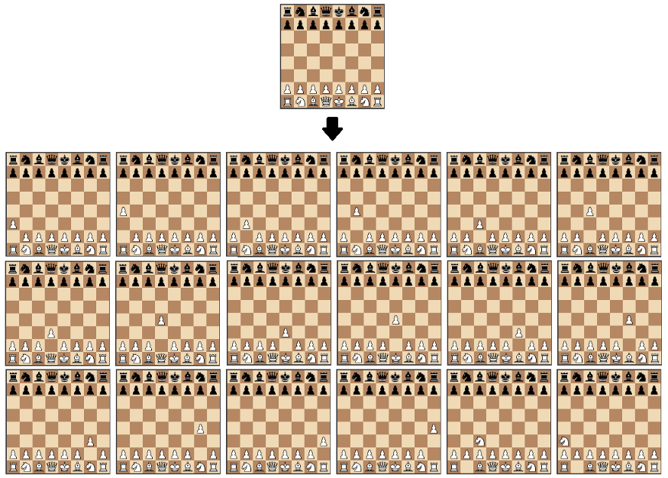

A visualization of the move generation function. The starting position is used as input and the output is all the possible moves from that position.

Using these libraries will help us focus only on the most interesting task: creating the algorithm that finds the best move.

We’ll start by creating a function that just returns a random move from all of the possible moves:

Although this algorithm isn’t a very solid chess player, it’s a good starting point, as we can actually play against it:



Black plays random moves. Playable on <https://jsfiddle.net/lhartikk/m14epfwb/>4

# Step 2 : Position evaluation

Now let’s try to understand which side is stronger in a certain position. The simplest way to achieve this is to count the relative strength of the pieces on the board using the following table:

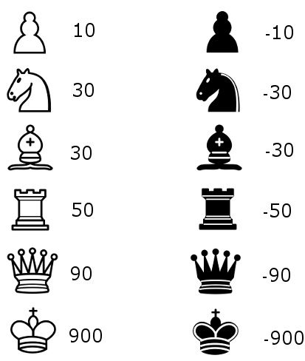

With the evaluation function, we’re able to create an algorithm that chooses the move that gives the highest evaluation:

The only tangible improvement is that our algorithm will now capture a piece if it can.



Black plays with the aid of the simple evaluation function. Playable on <https://jsfiddle.net/lhartikk/m5q6fgtb/1/>

# Step 3: Search tree using Minimax

Next we’re going to create a search tree from which the algorithm can chose the best move. This is done by using the [Minimax](https://en.wikipedia.org/wiki/Minimax) algorithm.

In this algorithm, the recursive tree of all possible moves is explored to a given depth, and the position is evaluated at the ending “leaves” of the tree.

After that, we return either the smallest or the largest value of the child to the parent node, depending on whether it’s a white or black to move. (That is, we try to either minimize or maximize the outcome at each level.)

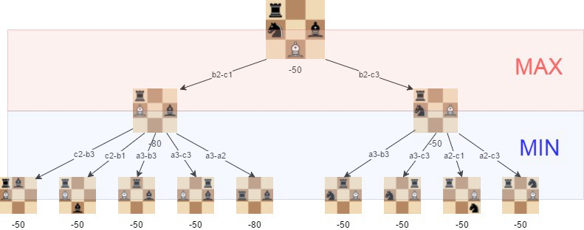

A visualization of the minimax algorithm in an artificial position. The best move for white is **b2-c3**, because we can guarantee that we can get to a position where the evaluation is **-50**

With minimax in place, our algorithm is starting to understand some basic tactics of chess:



Minimax with depth level 2. Playable on: <https://jsfiddle.net/k96eoq0q/1/>

The effectiveness of the minimax algorithm is heavily based on the search depth we can achieve. This is something we’ll improve in the following step.

# Step 4: Alpha-beta pruning

[Alpha-beta](https://en.wikipedia.org/wiki/Alpha%E2%80%93beta_pruning) pruning is an optimization method to the minimax algorithm that allows us to disregard some branches in the search tree. This helps us evaluate the minimax search tree much deeper, while using the same resources.

The alpha-beta pruning is based on the situation where we can stop evaluating a part of the search tree if we find a move that leads to a worse situation than a previously discovered move.

The alpha-beta pruning does not influence the outcome of the minimax algorithm — it only makes it faster.

The alpha-beta algorithm also is more efficient if we happen to visit **first**those paths that lead to good moves.

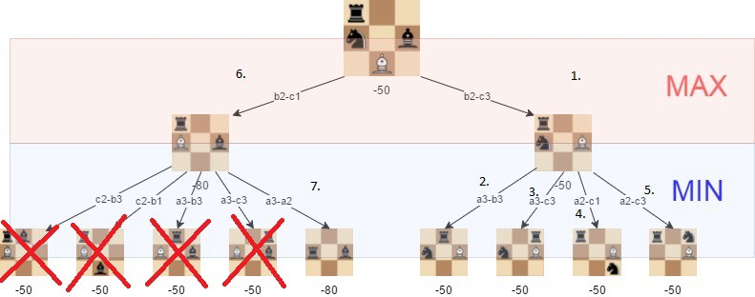

The positions we do not need to explore if alpha-beta pruning isused and the tree is visited in the described order.

With alpha-beta, we get a significant boost to the minimax algorithm, as is shown in the following example:

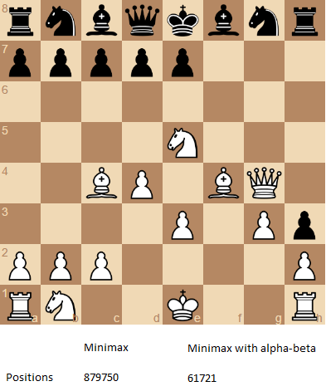

The number of positions that are required to evaluate if we want to perform a search with depth of 4 and the “root” position is the one that is shown.

Follow [this link](https://jsfiddle.net/Laa0p1mh/3/) to try the alpha-beta improved version of the chess AI.

# Step 5: Improved evaluation function

The initial evaluation function is quite naive as we only count the material that is found on the board. To improve this, we add to the evaluation a factor that takes in account the position of the pieces. For example, a knight on the center of the board is better (because it has more options and is thus more active) than a knight on the edge of the board.

We’ll use a slightly adjusted version of piece-square tables that are originally described in the [chess-programming-wiki](https://chessprogramming.wikispaces.com/Simplified+evaluation+function).

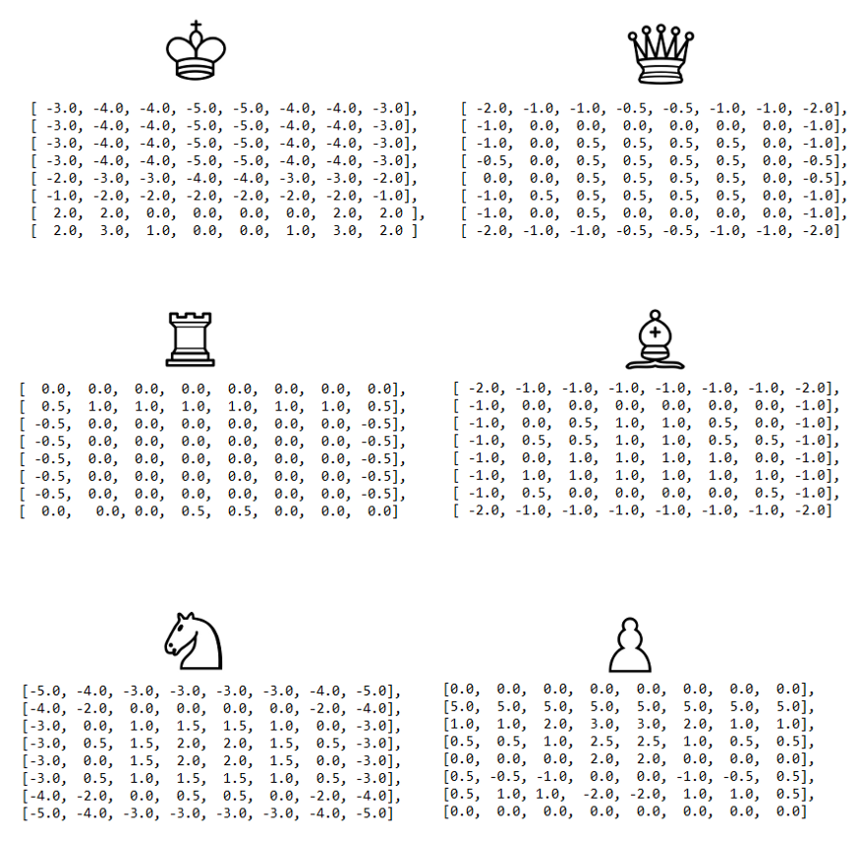

The visualized piece-square tables visualized. We can decrease or increase the evaluation, depending on the location of the piece.

With the following improvement, we start to get an algorithm that plays some “decent” chess, at least from the viewpoint of a casual player:



Improved evaluation and alpha-beta pruning with search depth of 3. Playable on <https://jsfiddle.net/q76uzxwe/1/>

# Conclusions

The strength of even a simple chess-playing algorithm is that it doesn’t make stupid mistakes. This said, it still lacks strategic understanding.

With the methods I introduced here, we’ve been able to program a chess-playing-algorithm that can play basic chess. The “AI-part” (move-generation excluded) of the final algorithm is just 200 lines of code, meaning the basic concepts are quite simple to implement. You can check out the final version is on [GitHub](https://github.com/lhartikk/simple-chess-ai).

Some further improvements we could make to the algorithm would be for instance:

* [move-ordering](https://chessprogramming.wikispaces.com/Move+Ordering)
* faster [move generation](https://chessprogramming.wikispaces.com/Move+Generation)
* and [end-game](https://chessprogramming.wikispaces.com/Endgame) specific evaluation.

If you want to learn more, check out the [chess programming wiki](https://chessprogramming.wikispaces.com/). It’s a helpful resource for exploring beyond these basic concepts I introduced here.

Thanks for reading!

12)

# Improving Valorant E-Sports Experience—UI/UX Case Study

13